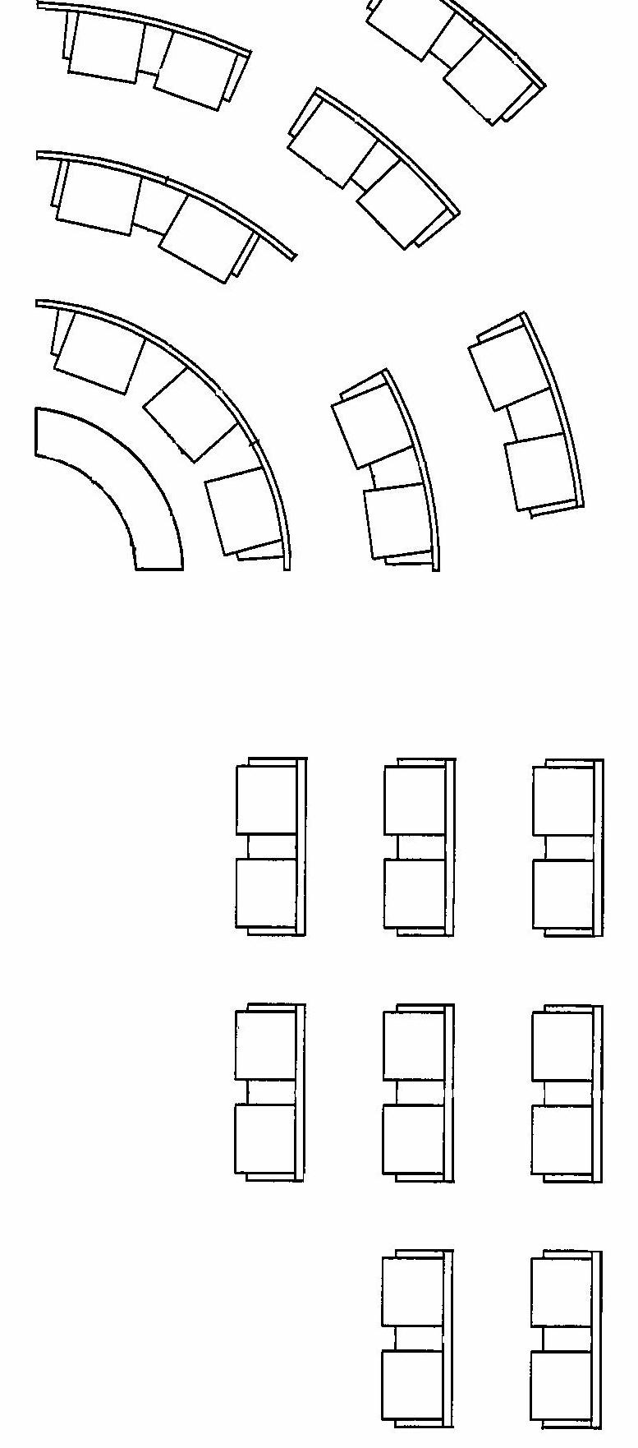

Please ensure you have filled in all the details required at the top.   
Please also mark up where each advisor will be sitting, please write their full names.

**ASAP** return the completed form to [laestimates@parliament.wa.gov.au](mailto:laestimates@parliament.wa.gov.au)

**COMMITTEE A - LEGISLATIVE ASSEMBLY CHAMBER ONLY   
DIVISION No. or Off budget:**

**Relevant Minister:**

**Hearing date/time block:**

8

9

18

17

16

15

14

13

The Minister

12

11

10

5

4

7

6

1

2

3



9

8

15

14

14