Projects and Innovation Lead
Classification: | Level 7
Type of employment: | Full Time – Non-Sessional
Unit: | Information Technology
Date last updated: | November 2022
This position reports directly to: | Chief Information Officer (CIO)
This positions Supervisor is responsible to: | Director Parliamentary Information and Education
Number of staff reporting to this position: | One

About the Unit
The Information Technology Unit provides all IT support services for parliamentary departments and IT services to members when they are at Parliament House. It does this with a focus on customer service, quality solutions, and appropriate responsiveness. The unit also develops and implements proper standards, policies and plans; maintains an appropriate information technology hardware/software/cloud infrastructure; manages the Parliament’s unified-communications systems; and ensures the efficient and effective operation of all computer systems in alignment with the strategic and operational needs of the departments.

Primary Responsibilities
- Coordinate project activities related to technology projects, including project management, scheduling and reporting.
- Assist the CIO in the implementation of the ICT Strategic Roadmap.

Specific Duties

Leadership and Consultation
- Supervise the operations of Projects and Innovation area, including team leadership, planning and development.
- Champion innovation, continual improvement and quality management.
- Develop and maintain strong relationships with internal and external stakeholders.
- Assist, and when necessary, deputise for the CIO.

- Project Management
- Undertake project management activities for significant ICT related projects, including scheduling, directing and reporting on.
- Make decisions within approved remit (or refer to the CIO) in regards to Project scope, budget, timeframe and quality.
- Coordinate work allocation in cross-functional teams.
- Facilitate collaborative and effective working relationships between teams, areas, functions, and business units of the organisation.
- Negotiate with various project stakeholders (including users, suppliers and the project board) to secure consensus on project decisions.
- Governance
- Work with the IT business unit and broader organisation to build and maintain a strong IT project management framework and processes.
- Work with the IT business unit and broader organisation to build and maintain an Innovation Framework (with suitable processes and procedures), to support the surfacing of innovative ideas and their progression to business cases and possible projects.
- Reporting and Recording
- Provide oral and written briefing/reports on the status of each project.
- Report significant variations to project objectives, such as budget, timeline and outcomes.
- Record decisions, document changes and map system modifications.
- Innovation and Continuous Improvement
- Operate a business analysis and solution design service for all areas of the organisation, to streamline processes and find ways to improve effectiveness, efficiency or service delivery (including the development of business cases and project artefacts).
- Operate an Innovation Program and Idea Management system, to bring improvement and innovation ideas to the attention of the CIO, for submission to the Heads of Department via the ICT Governance Committee.
- Facilitate the effective transition of approved innovation ideas to active projects.

Selection Criteria

Essential
- Relevant Tertiary Qualification relating to business, project management, quality management or a related field.
- Demonstrated experience managing and coordinating significant ICT projects to achieve outcomes aligned to organisational strategy.
- Demonstrated experience in innovation, business improvement, continuous improvement, project management, quality management or a related field.
- Demonstrated experience in dealing with diverse stakeholder groups and representatives to obtain requirements and accurately reflect these.

Desirable
- Experience in the development and operation of a quality management system.

Competencies

COMMUNICATION
Expressing ideas effectively in individual and group situations (including non-verbal communication); adjusting language or terminology to the characteristics and needs of the audience. Expressing ideas clearly in documents that have organisation, structure, grammar, language, and terminology adjusted to the characteristics and needs of the audience.

FORMAL PRESENTATION

Presenting ideas effectively to individuals or groups when given time for preparation (including non-verbal communication and use of visual aids); targeting presentations to the characteristics and needs of the audience.

ORGANISATIONAL AWARENESS
Having and using knowledge of systems, situations, procedures and culture inside the organisation to identify potential organisational problems and opportunities; perceiving the impact and the implications of decisions on other components of the organisation.

NEGOTIATION
Effectively exploring alternatives and positions to reach outcomes that gain all parties’ support and acceptance.

MEETING FACILITATION/MEETING LEADERSHIP
Using appropriate interpersonal styles and methods to guide participants toward a meeting’s objectives; modifying behaviour according to tasks and individuals present.

INDIVIDUAL LEADERSHIP/INFLUENCING
Using appropriate interpersonal styles and methods to inspire and guide individuals (direct reports, peers and superiors) toward goal achievement; modifying behaviour to accommodate tasks, situations, and individuals involved.

PLANNING AND ORGANISING/WORK MANAGEMENT

Establishing a course of action for self and/or others to accomplish a specific goal; planning proper assignments of personnel and appropriate allocation of resources.

TOLERANCE FOR STRESS
Maintaining stable performance under pressure and/or opposition (such as time pressure or job ambiguity); relieving stress in a manner that is acceptable to the person, others and the organisation.

Unit Organisational Structure

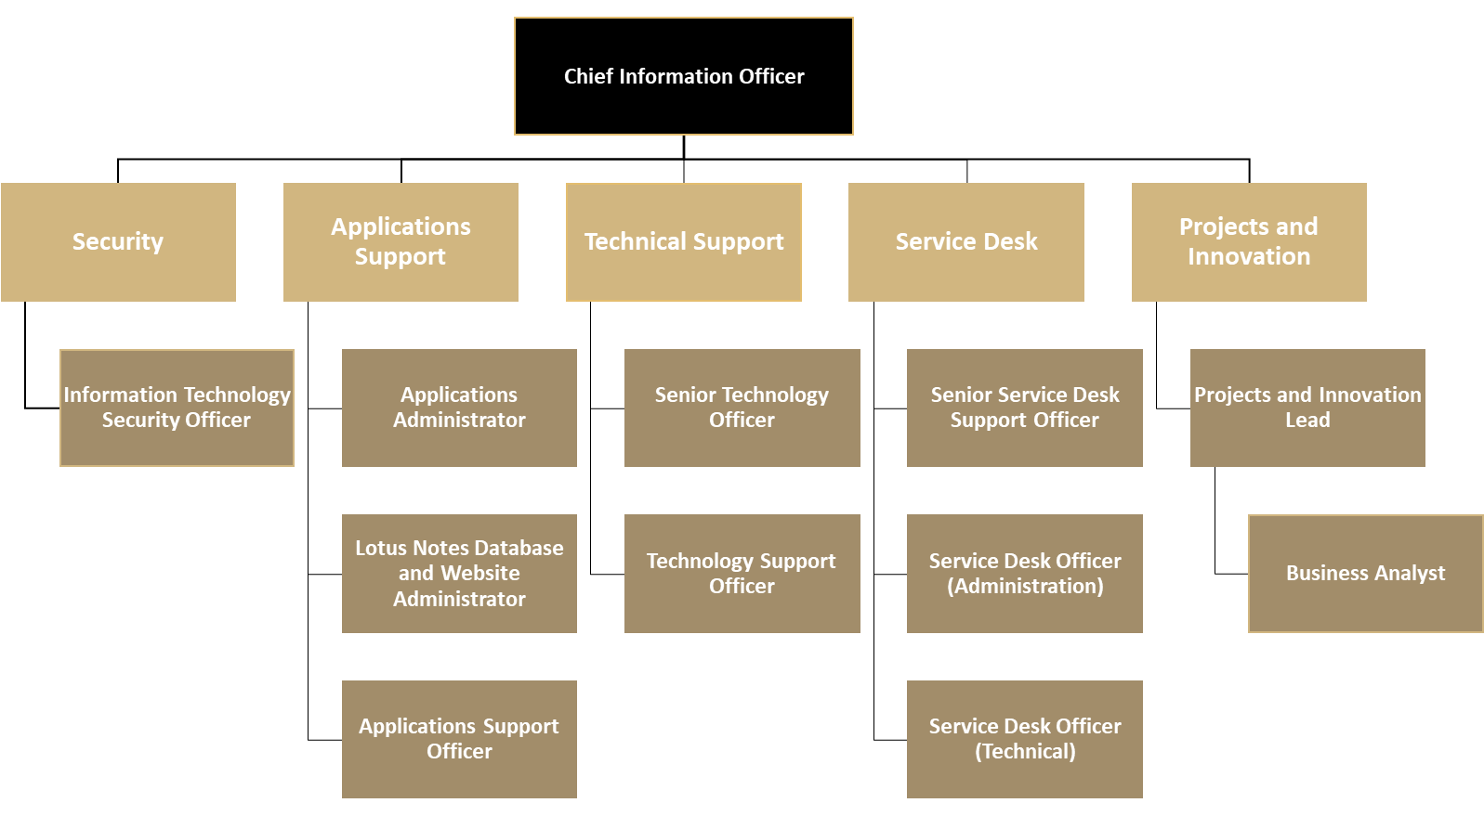

Parliamentary Services Department Values
Parliamentary Services Department staff are expected to embrace the following four values, which underpin positive culture and behaviours.
Professional – Showing respect and professionalism in all aspects of work.
Accountable – Being honest and trustworthy in performance of our public duties.
Transparent – Maintaining fairness and consistency.
Helpful – Cooperation among teams and with others while always showing encouragement.

Further Information
- Provision of a National Police Clearance not more than twelve months old will be required prior to commencement in this position.
- Applicants must be an Australian citizen or permanent resident.
- Applicants may be required to undertake skills or psychometric testing.

Acknowledgement
I acknowledge that my supervisor has explained this job description to me:
_________________________ ____________________ Date: _______________
Employee Name Employee Signature
_________________________ ____________________ Date: _______________
Supervisor’s Name Supervisor’s Signature

